APPROVED
AB “Lietuvos geležinkeliai”
Chief Executive Officer
on __________ ___ 2026
Decision No.

SAFETY MANAGEMENT PRINCIPLES

Purpose and scope of application
  - The Safety Management Principles (hereinafter referred to as the ‘Principles’) establish a unified model for safety management within the LTG Group of companies, as well as the general principles for the development and implementation of organizational and technical measures designed to actively foster a safety culture and ensure a high level of safety.
  - The implementation and application of the Principles are defined in detailed internal regulations (methodologies, process standards, rules, etc.). The management of information security and personal data protection is set out in detail in the management principles for these areas of security.
  - These Principles apply to all companies within the LTG Group. The scope of application of the detailed documents (methodologies, process standards, rules, etc.) is determined at the time of their approval.
  - With regard to companies within the LTG Group that perform the functions of a public railway infrastructure manager, the provisions of these Principles shall apply to the extent that they do not conflict with the principles of autonomy, independence, financial transparency, the prohibition on cross-subsidization of activities, or other operating conditions laid down in legislation.

Definitions

  - The following terms and abbreviations are used in these principles.
Term / Abbreviation | Definition / Explanation
Assets | Resources with economic value that the LTG group of companies uses and/or controls, in the expectation that they will provide future benefits
Rail transport operations | The carriage of passengers, luggage and/or freight by rail; the management, development and maintenance of railway infrastructure; and other activities directly related to railway infrastructure and the carriage of passengers, luggage and/or freight.  The scale of operations is characterized by the total number of passengers or the volume of freight carried by the operational unit, the number of employees working for the organization and/or the length of railway lines managed. These figures are published on the company’s website at https://ltg.lt/, alongside the annual activity reports of the LTG Group and each Business Unit.
KC | UAB “LTG Competence Centre”
KC Safety | UAB “LTG Competence Centre” Safety
Control measures | Safety measures designed to control emerging or existing safety risks
LTG | AB “Lietuvos geležinkeliai”, understood as the parent company of the LTG group of companies, which performs management (holding) functions within its subsidiaries.
LTG Group | A group of companies comprising LTG and the entities it controls, either directly or indirectly
LTG Management | The holding company’s managers who lead or control the LTG Group at the highest level: the LTG Chief Executive Officer and the LTG HR-L2 level managers reporting directly to him, as well as the LTG Group Board.  LTG’s management reports on operational results to the LTG Group’s Annual General Meeting of Shareholders.

Term / Abbreviation | Definition / Explanation
LTG Strategy | An operational planning document that defines the overall direction of the LTG Group’s development and sets out operational objectives and targets for a period of not less than five years
Safety | The absence of an unacceptable risk of harm. Safety encompasses all technical and organizational measures designed to ensure the safe operation of rail transport, as well as fire safety, civil protection, environmental protection, the physical security requirements for LTG Group facilities and assets, as well as measures to safeguard employees’ fitness for work, health and life at work. These measures also include preventative activities to ensure that passengers, other road users and other persons, as well as railway infrastructure, rolling stock and the goods and luggage being carried, are protected from railway accidents, incidents and their consequences
Safety event, incident | A technical, environmental or social event caused by the activities of an LTG Group company, which has caused harm to human health, people’s basic living (or operational) conditions, property and/or the environment, the performance of vital state functions, or public order; any other breach of safety requirements that provokes the aforementioned events and/or causes or may cause a negative impact on safety (including near-misses).  Security incidents also include breaches of personal data and physical security, information and cyber security incidents, unlawful interference with Assets, and insured events.
Safety Level | The safety status of specific operations within the LTG Group, assessed according to established criteria
Security non-compliance | Failure to meet a defined security requirement
Security measures | A set of measures designed either to reduce the frequency of incidents or to mitigate their consequences, in order to achieve and/or maintain an acceptable level of risk.
Safety risk | The potential possibility or uncertainty that adverse factors may occur in the future which could affect safety. The level of safety risk can be assessed as:  - The ratio of the frequency of safety-related incidents resulting in harm caused by a hazard to the severity of that harm;  - The ratio of the degree of potential harm to an employee’s health caused by harmful and/or hazardous factors in the working environment to the probability of exposure to these factors.
Safety risk management | Management strategies, procedures and activities systematically applied to carry out safety risk analysis, assessment and management tasks
Safety objectives | The desired outcomes of safety management.
Safety management system | The totality of measures established by the organization to ensure that it carries out its activities safely (with regard to all safety aspects).
Standardization | The establishment of uniform standards and requirements

Term / Abbreviation | Definition / Explanation
Monitoring | Measures taken by the organization to ensure the suitability and effectiveness of the Safety Management System.
Heads of structural units | HR managers and specialists at L3–L5 level within operational units who are directly involved in safety management and/or have an indirect impact on safety. Heads of structural units report on operational results to the Executive Board.
Identity characteristics | Gender, race, nationality, citizenship, language, origin, social status, religion, beliefs or views, age, sexual orientation, disability, ethnicity, health status, marital and family status, membership of a political party, trade union or association, religion, intention to have a child, an employee’s exercise of rights provided for by law, circumstances unrelated to the employee’s professional qualities, or any other factor unrelated to the employee’s professional qualities.
Operating unit (OU) | A company belonging to the AB ‘Lietuvos geležinkeliai’ group of companies, excluding LTG and KC. A structural unit of LTG or KC that carries out rail transport activities (as a carrier or infrastructure manager) is treated as equivalent to a business unit.
BU Top-level management | Managers who lead or control the Business Unit at the highest level: the Business Unit’s Chief Executive Officer (CEO) and HR-L2 level managers reporting directly to him, as well as the BU Board, which, taking into account the decisions of the LTG Management, shapes the strategic direction and methods of BU’s operations, enabling progress towards the fulfilment of the LTG Group’s vision, the execution of its mission and the achievement of its business objectives.  BU management reports on safety performance to the LTG management.

Other terms used in these Principles are to be understood as defined in the Railway Transport Code of the Republic of Lithuania, the Law on Railway Transport Safety of the Republic of Lithuania, the Law on Occupational Safety and Health of the Republic of Lithuania, the Law on Environmental Protection of the Republic of Lithuania, the LTG Operational Architecture Principles and other legislation.

Safety management goals and objectives
  - As the LTG Group carries out its day-to-day operations, as well as when entering new areas of operation, increasing and diversifying revenue streams, and striving for greater operational productivity, efficiency and flexibility, it is essential to continuously manage the safety risks arising from day-to-day operations and changes, to ensure compliance with legal requirements, thereby ensuring a high level of safety.
  - The objective of safety management is to develop and implement a targeted, unified and innovative safety management model, integrated into operations, which would ensure the safe and effective operation of the LTG Group of Companies and its sustainable development, as well as the implementation of the business strategy, whilst fostering a safety culture and ensuring a high level of employee awareness, where a safe and healthy working environment becomes an integral part of every employee’s work, regardless of their individual characteristics, yet tailored as far as possible to the needs of each individual.
  - In order to manage safety risks arising from its own and/or other entities’ activities, taking into account the results of safety monitoring and risk management analysis, safety-related objectives are formulated annually in each business unit, as set out in the strategies of the LTG Group companies and updated where necessary; these objectives aim to achieve 0 (zero) incidents, i.e. safe rail transport operations and a safe working environment, to minimize the negative impact of operations on the environment and climate change, and to protect the assets of the LTG Group of companies.
  - The main objectives of safety management relate to ensuring compliance with legal requirements and implementing safety requirements in each area of safety, including:
    - health and safety at work: ensuring safe and healthy working conditions for employees in all work-related aspects, including the development of measures to promote health and psychological wellbeing, by carrying out the functions of the occupational health and safety service; the implementation of preventive measures (technical, medical, legal, organizational and other) aimed at preventing accidents at work and occupational diseases, by establishing procedures for the implementation and monitoring of these measures;
    - railway transport safety: the entirety of technical and organizational measures in railway transport designed to ensure that passengers, affected communities, other road users and other persons, as well as the railway infrastructure, railway rolling stock, and the freight and luggage being carried are protected from railway disasters, traffic incidents, derailments and their consequences, as well as unlawful acts by other persons;
    - asset security: the protection of the LTG Group’s assets against theft, destruction or damage, the management of insurance cover and the minimization of related financial losses;
    - Environmental protection: protecting the environment from physical, chemical, biological and/or other impacts or consequences arising from the LTG Group’s business activities or the use of natural resources, as well as monitoring and mitigating the impact on climate change;
    - physical security: the protection of the LTG Group’s premises against emerging threats and undesirable incidents, by organizing physical security measures and controlling access to the premises;
    - fire and civil safety: fire prevention and ensuring preparedness for emergencies and/or incidents;
    - personal data security: the effective protection of personal data being processed and the prevention of potential breaches in the field of personal data protection, by encouraging greater involvement of staff and managers to ensure the ability to identify potential personal data processing breaches in a timely manner;
    - information security: threats arising from careless, negligent, deliberate or malicious acts, or vulnerabilities among staff handling information, and cyber security incidents which may disrupt the operations of the LTG Group and (or) the operations of the Business Unit, or cause financial or reputational damage; management ensuring the confidentiality, availability and integrity of information;
    - security regulation: documentation of security-related matters; ensuring the acquisition and timely renewal of the security authorizations and certificates necessary for the conduct of operations.
  - Safety management objectives are also linked to sustainability priorities in the environmental and social spheres, where, through cooperation with institutions, partners and stakeholders, the safety risks posed by the LTG Group’s operations are managed and opportunities for sustainability are developed, thereby reducing the level of risk to the public, affected communities, value chain employees, customers and end users.

The role of the safety function within the LTG Group

The governance of the safety function within the LTG Group is centralized; its operating model is standardized, and the roles implementing this model are partially centralized.

Within the LTG Group, the functional leader and service provider for safety is KC Safety, which, by carrying out centralized safety management functions, aims to ensure the following in each Business Unit (see Fig. 1):
    - the integrity and harmonious functioning of the various elements (components) of safety management;
    - the implementation of safety-related processes;
    - compliance of the LTG Group’s operations with the requirements of legislation governing safety.
Fig. 1. The role of safety management within the LTG Group

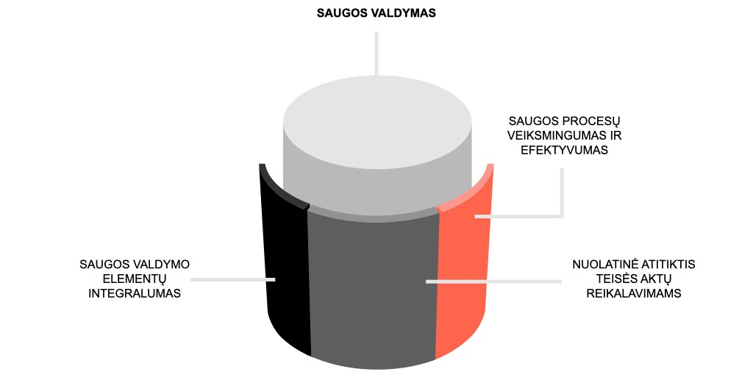
With a view to achieving standardized and effective safety management across the entire LTG Group, KC Safety provides centralized safety services to the business units, ensuring the foundations of safety management, which consist of:

a safety management system, system that includes the development and maintenance of a security management system. When forming the Security Management System for Operational Units, provisions are followed that:

when an undertaking carries out rail transport activities, safety management must comply with Commission Delegated Regulation (EU) 2018/762 of 8 March 2018 laying down common safety methods related to safety management system requirements and repealing Commission Regulations (EU) No 1158/2010 and (EU) No 1169/2010 (Text with EEA relevance) (hereinafter - Regulation (EU) 2018/762), requirements, and includes the creation and maintenance of the system description as well as ensuring the conditions for certified activities;

When a company conducts production activities and as a result its employees work under occupational risk factors and/or the company's activities may negatively affect the environment or property, the operation of the safety management system is regulated in accordance with the international safety management standards LST EN ISO 4500145001 (Occupational Health and Safety Management Systems). Requirements and application instructions), LST EN ISO 45004 (Management of occupational safety and health). Effectiveness assessment guidelines) and/or LST

EN ISO 14001 (Environmental Management Systems. Requirements and usage guidelines) (hereinafter – ISO standards), fire and civil safety regulatory legal acts. When a company simultaneously carries out railway transport activities, safety management system descriptions may be equated;

The security management of LTG Group companies conducting solely administrative activities is handled individually and regulated by local legal acts;

management of safety risks and changes, including the assessment of safety risks arising from the activities of the organization and other entities, and the identification of measures to eliminate and/or reduce them to a tolerable level, as well as the management of changes in internal and external circumstances relating to safety;

management of safety competencies, ensuring that the staff of the company and other entities involved in its operations possess the necessary level of competence – including knowledge, skills and health status – to perform their assigned work safely and to carry out tasks essential to ensuring safety;

assessment and improvement of safety performance, ensuring the proper implementation of the safety management system and continuous improvement of operations, including the management of safety non-conformities and safety investigations. Centralized safety services are provided within the LTG Group where there is a need for standardized services across the entire LTG Group and/or where the centralized provision of services ensures their more efficient delivery or a higher quality of service. The key objectives of safety management (see section 4.3) are implemented in the business units by KC Safety, unless, for objective reasons (differences in national legislation, etc.), the LTG management decides otherwise.

KC Safety services are defined in the KC safety services catalog, whilst the key elements of safety management and the persons, functions and responsibilities for their implementation, taking into account the process standards of the LTG Group and the Business Unit and the relevant operational procedure manuals, instructions or decisions, are detailed in the descriptions of the business units’ safety management systems and organizational charts, or in other documents where the description of safety management systems is not mandatory.

The business unit sets out the implementation of decentralized safety management activities in its process management documents, ensuring a level of safety management no lower than that stipulated in Regulation (EU) 2018/762 and other EU and national legislation, and, having coordinated the implementation arrangements with the KC Safety Manager and, where necessary, the LTG Business Resilience Director, documents this in the safety management system.

Taking into account the specific features of national legislation governing safety, differences in language proficiency and the geographical distance at which operations are carried out, standardized safety services are not provided to business units of the LTG Group that are registered and operating in other countries. In accordance with the requirements of European Union and national legislation, as well as these Principles, including point 4.3.1, must develop a safety management system, to be agreed with KC Safety, which, in accordance with Regulation (EU) 2018/762, sets out the safety requirements arising from legislation, and the persons responsible for them (or engage external consultants). To ensure the proper functioning of safety management within the aforementioned operational units, companies must regularly provide KC Safety with safety-related information agreed in advance, and, in the event of deviations from safety indicators, must plan and report on the measures to be taken to ensure the proper functioning of the safety management system.

Safety Management Principles

Safety management across the entire LTG group of companies is based on international safety management standards (LST EN ISO 45001, LST EN ISO 45004, LST EN ISO 14001:2015, ISO 22301), Commission Delegated Regulation (EU) No 2018/762, which, pursuant to Directive (EU) 2016/798 of the European Parliament and of the Council, lays down general safety measures relating to the requirements for safety management systems and repeals Commission Regulations (EU) No 1158/2010 and (EU) No 1169/2010, as well as Commission Implementing Regulation (EU) No 402/2013, which lays down a common safety method relating to hazard identification and hazard assessment, and repealing Regulation (EC) No 352/2009, as well as other European Union and national legislation, and is implemented in accordance with the following six key principles (see Figure 2):
    - Fostering a safety culture – The LTG Group fosters an integrated safety culture and ensures a high level of employee awareness, where a safe and healthy working environment becomes an integral part of every employee’s work.

Systematic approach – The LTG Group implements comprehensive and systematic safety measures, ensuring the safety of all activities carried out by the LTG Group and its business environment as a whole, rather than just individual parts of it;

Proportionality – The safety measures implemented within the LTG Group are focused on the highest-risk areas of operation, where the greatest threats to safety arise or where they are most likely to occur in the future;

Innovation – Security is managed using the most advanced technological and operational management solutions, geared towards the effective management of threats arising during the Fourth Industrial Revolution and the exploitation of opportunities;

cooperation – close mutual cooperation is encouraged, along with the involvement of operational functions and units in safety management, the joint resolution of emerging challenges and the fostering of a safety culture;

transparency – Safety is managed in accordance with consistent, clear and documented decisions, and safety-related information is made publicly available to stakeholders.
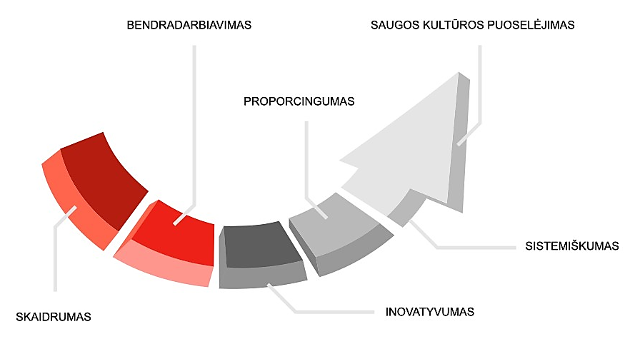
Fig. 2. Key principles for the implementation of safety management functions
- Safety management model
  - Safety management within the LTG Group is ensured in accordance with the business strategy and taking into account the assessment of the effectiveness of each company’s Safety Management System, by applying a unified operational model and standardizing activities as much as possible with a view to centralizing them.

To implement these principles in accordance with the standard safety management model, each business unit operates in line with Regulation (EU) 2018/762, the international management system standards ISO 45001 (Occupational health and safety management systems – Requirements and guidance for use) and ISO 14001 (Environmental management systems – Requirements and guidance for use) and national legislation setting out general safety measures relating to safety management system requirements, the company’s Safety Management System is established, the guidelines for which are described in the management manual for this system.

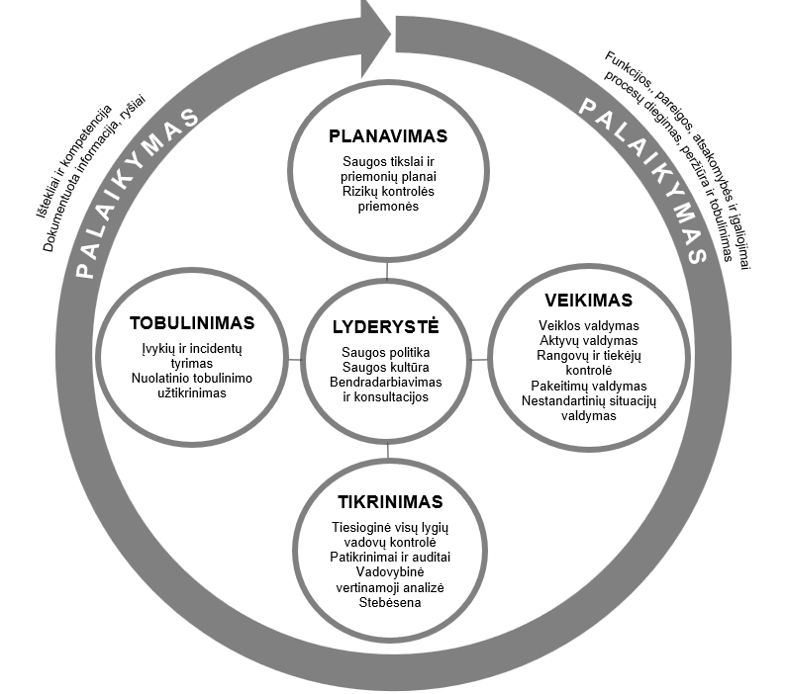
The Safety Management System integrates the key elements of safety management, forming the Plan-Do-Check-Act (PDCA) cycle (see Figure 3) and comprising four (4) stages:
Fig. 3. Elements (components) of the safety management model
    - Planning. The greatest safety hazards are identified, analyzed and risk control measures are selected to reduce the risks arising from the organization’s own activities, as well as those posed by other entities, to the lowest reasonable level (ALARP).
    - Operation. In collaboration with representatives of functional departments and business units, safety measures are implemented to achieve the established safety objectives and ensure a high level of safety; emerging issues are resolved, and expert assistance and advice are provided.
    - Inspection. The safety status is monitored and its effectiveness assessed; analyses, safety inspections and audits are carried out.
    - Improvement. Comprehensive investigations are carried out in order to properly assess the circumstances of safety events and incidents, identify their root causes, and take immediate and appropriate action to prevent the recurrence of the causes of such incidents.
Taking into account the results of investigations and monitoring, systematic proposals are made for adjustments to the LTG Group’s operations in line with best practices from other sectors or other countries, and innovative safety solutions are sought and implemented, considering the opportunities offered by the Fourth Industrial Revolution (Industry 4.0).
  - To ensure comprehensive and effective safety management within LTG Group companies, the ‘Plan, Do, Check, Act’ cycle has been supplemented with safety management elements that function as integral parts at every stage of the model:
    - leadership, which ensures the proper functioning of the safety management model, a high level of safety culture amongst staff – where staff look after their own safety and that of their colleagues – and the effective involvement of staff in safety management, empowering them to make suggestions for improving safety levels;
    - support, which ensures comprehensive, standardized management of the Safety Management Model, documentation, a high level of staff competence, and the development of functional management, as well as the implementation, review and improvement of processes.
- Safety Management Roles and Responsibilities
  - The following parties are involved in Safety Management within the LTG Group (see Figure 4):
    - the LTG Group Board and the Board’s Audit Committee, which set the LTG Group’s development directions and strategic objectives, enabling the Group to move safely towards the fulfilment of its vision and the execution of its mission, and which assesses the results of safety performance;
    - the LTG Chief Executive Officer, who encourages and obliges managers and employees at all levels across LTG Group companies to ensure safety in accordance with their respective areas of competence, approves these Principles, and monitors and takes responsibility for the outcomes of safety management within the LTG Group;
    - The LTG Business Resilience Director, by planning and coordinating the strategic directions of safety management activities, monitoring their implementation and the achievement of safety outcomes, and developing the safety function, coordinates the creation of the safety management model within the LTG Group and monitors and controls its operation.
    - LTG Risk and Compliance ensures a consistent and principles-based system of risk management and compliance with legal requirements across the LTG Group of companies, which helps operations to manage emerging risks and ensure compliance with legislation;
    - The Head of the Control Centre, whilst managing the operations and tools of the LTG Control Centre, coordinates the high-quality and efficient provision of security services;

The KC Safety Manager ensures the high-quality and efficient provision of safety services and their continuous improvement, establishes centralized safety management processes, and assists the operational units in ensuring the effective functioning of the safety management model;
    - Top-level management of the Business Units:
      - by assuming overall accountability and responsibility for safety, the functioning or failure of the safety management system and the final outcomes, ensures that managers at various levels within the Business Unit and other authorized persons, in carrying out their duties and liaising with employees, contractors and partners, are committed to ensuring safety and encourages staff to become actively involved in implementing the requirements of the safety management system and in improving it;
      - ensures that the business unit’s safety policy and objectives are established, that there is a common understanding of them, and that they are aligned with the strategic directions of the business unit’s operations;
      - ensures that the company’s Safety Management System is developed, implemented and put into practice, and monitors both its implementation and safety-related outcomes;
      - integrates the requirements of the safety management system into business processes and ensures its effectiveness by assessing and managing emerging risks;
      - encourages staff to comply with safety requirements and to improve the safety management system and fosters a positive safety culture.
    - Business resilience partners and/or safety coordinators within the business units, who, where necessary and subject to agreement with the LTG Business Resilience Director, are appointed by BU’s top-level management, and who ensure coordination between Business Resilience and the operational unit, providing assistance in pre-defined areas in implementing and improving the safety management system.
    - Heads of organizational units and other responsible persons ensure the day-to-day implementation of their assigned functions and safety management system tasks, and assume the associated responsibility.
    - LTG Internal Audit, which audits and assesses safety management activities at all specified levels, provides recommendations, suggestions and comments for improving operations and rectifying identified shortcomings.
  - Cooperation with safety authorities, agencies and organizations in the event of incidents, occurrences or inspections, safety certification procedures are carried out with the participation of the Safety Control Centre or, acting on its behalf, the operational unit in accordance with the powers granted.

Safety-related functions may be delegated, i.e. delegated by granting authorisation and transferring responsibility for the performance of these functions to a subordinate, where such delegation of functions and transfer of responsibilities is possible, taking into account the scope of these functions and the limits of competence. The delegation of safety functions must be documented.

Safety responsibilities are not only assigned to persons accountable for or responsible for safety processes and procedures (the process owner and process manager), but also cover all functions related to the implementation of safety management tasks, including those that do not directly participate in safety management and (or) have an indirect impact on safety (e.g. assigning tasks, planning activities and providing employees with activity-related information, carrying out supervision), including operational staff and regardless of their hierarchical level within the organization.

Those involved in safety management activities must report to senior management on the performance of the Safety Management System. Responsibilities in the field of safety may not be delegated (transferred). Safety-related tasks shall be communicated and accepted, and evidence thereof shall be provided and recorded in accordance with the procedures and processes established by the Safety Management System.

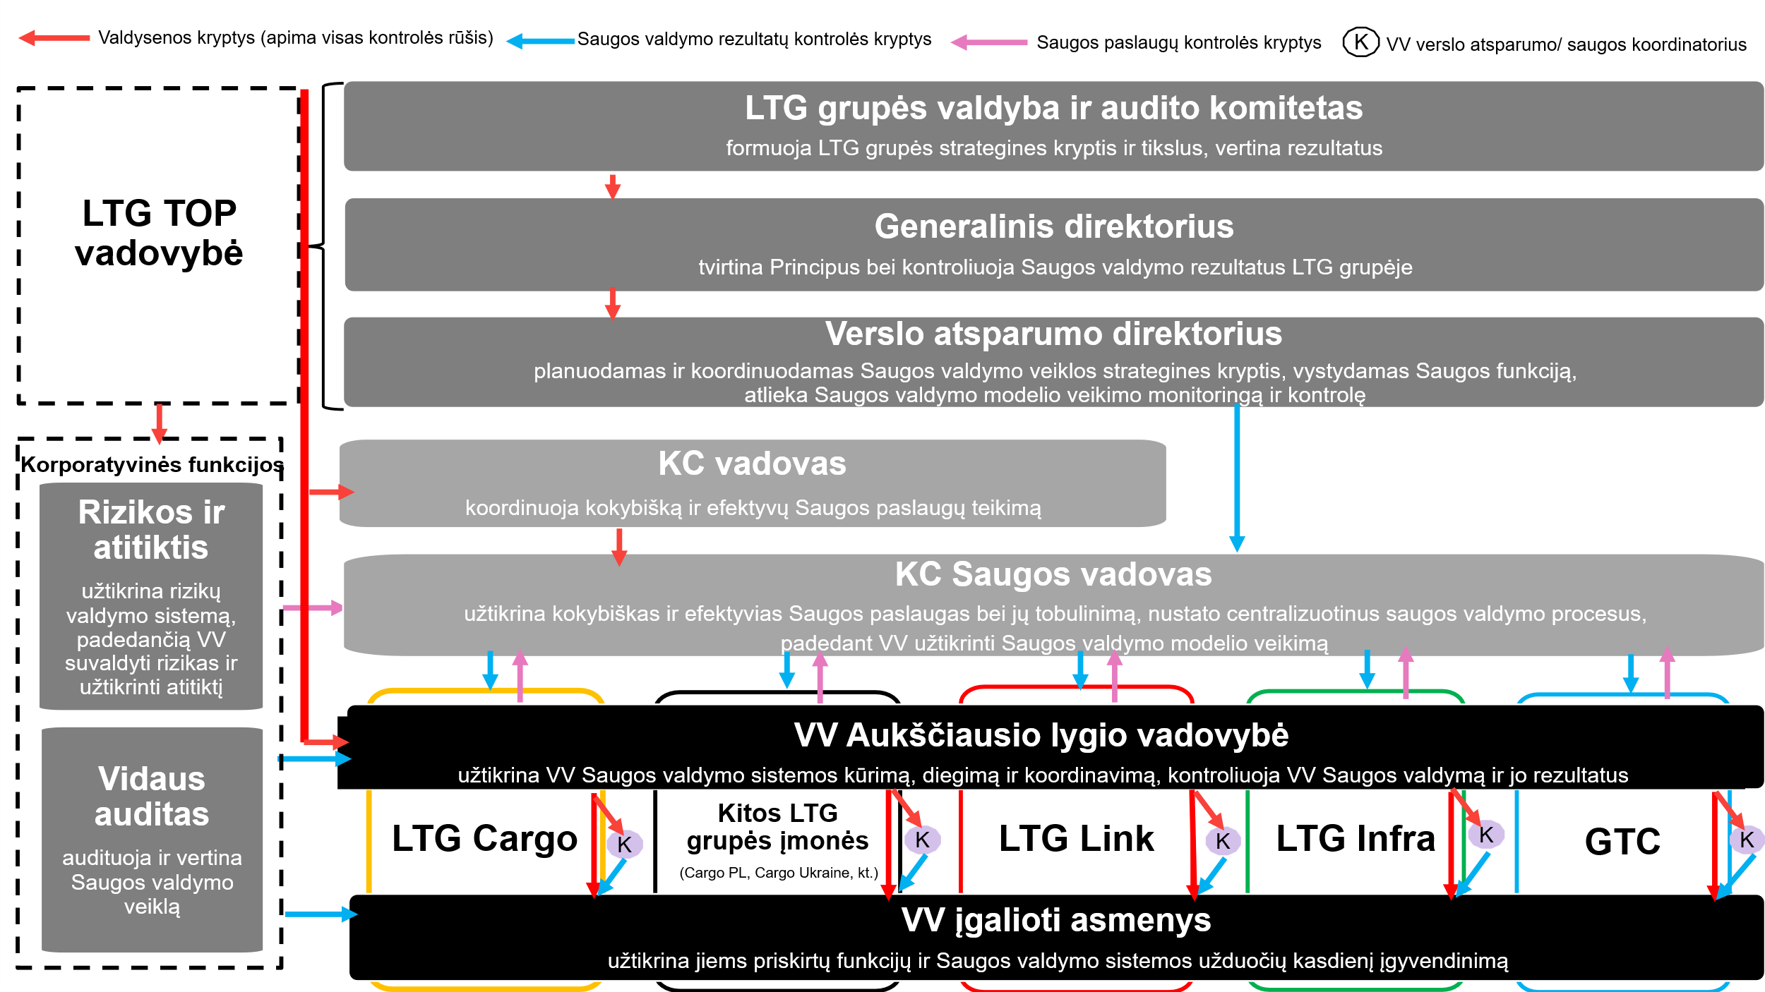
Fig. 4. Roles in the safety management model

- Final Provisions
  - These Principles and any amendments thereto shall be approved by the LTG Chief Executive Officer.
  - The review and updating of the Principles shall be initiated and coordinated by the KC Safety Manager.
  - The Principles are reviewed at least once a year, following any significant changes to LTG’s long-term strategy, changes to the organizational management structure of the LTG group of companies, changes to operational functions, or changes to the requirements of applicable legislation.
  - These principles apply to the extent that they do not conflict with current legislation.
______________________

